**《Fundamentals of Electric Circuits》homework CH.10&11**

**10.7 Use nodal analysis to find V in the circuit of Fig. 10.56.** (10’)

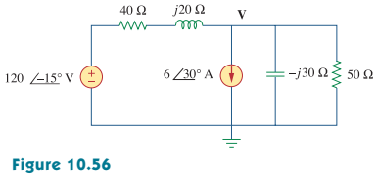

**10.28 In the circuit of Fig.10.76, determine the mesh currents *i1* and *i2*.**

**Let *v1* = *10 cos 4t V* and *v2* = *20 cos(4t - 30°) V*.** (10’)

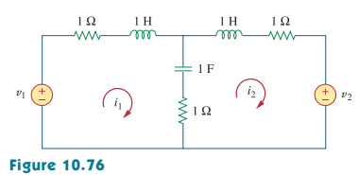

**10.45 Use superposition to find *i(t)* in the circuit of Fig. 10.90.** (10’)

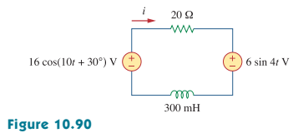

**10.66 At terminals *a-b*, obtain Thevenin and Norton equivalent circuits for the network depicted in Fig.10.109. Take *w* = 10 rad/s.** (10’)

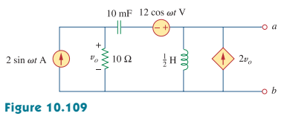

**10.79 For the op amp circuit in Fig. 10.122, obtain *vo(t)*.** (10’)

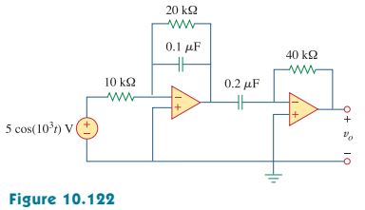

**11.6 For the circuit in Fig.11.38,*is* = *6 cos 103t A*. Find the average power absorbed by the *50 Ω* resistor.** (10’)

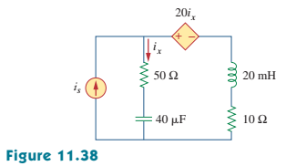

**11.18 Find the value of *ZL* in the circuit of Fig.11.49 for maximum power transfer.** (10’)

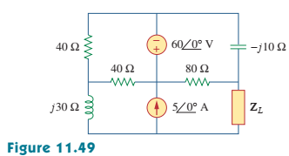

**11.27 Calculate the rms value of the current waveform of Fig. 11.58.** (10’)

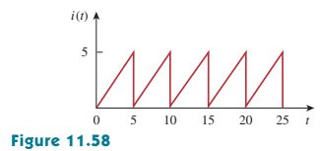

**11.41 Obtain the power factor for each of the circuits in Fig.11.68. Specify each power factor as leading or lagging.** (10’)

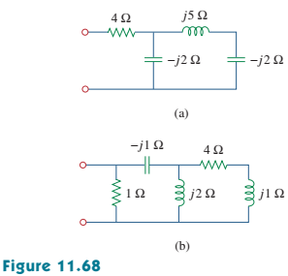

**11.53 In the circuit of Fig. 11.72, load A receives 4 kVA at 0.8 pf leading. Load *B* receives 2.4 kVAat 0.6 pf lagging. Box *C* is an inductive load that consumes 1 kW and receives 500 VAR.**

**(a) Determine I.**

**(b) Calculate the power factor of the combination.** (10’)

